### Homework 3

Name: Eduardo Wang Zheng

E-mail: eduardo@sjtu.edu.cn

1. Experiments

1.1 Install Libvirt , IDLE and dependences

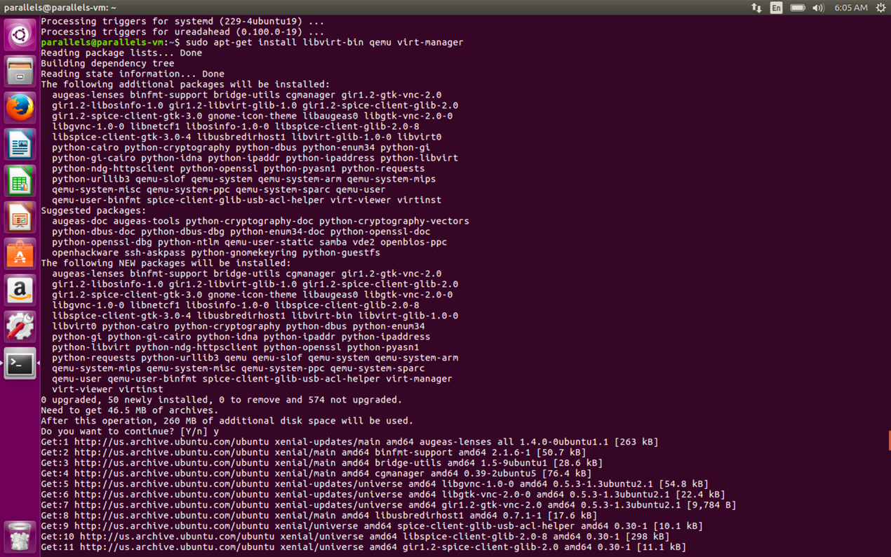

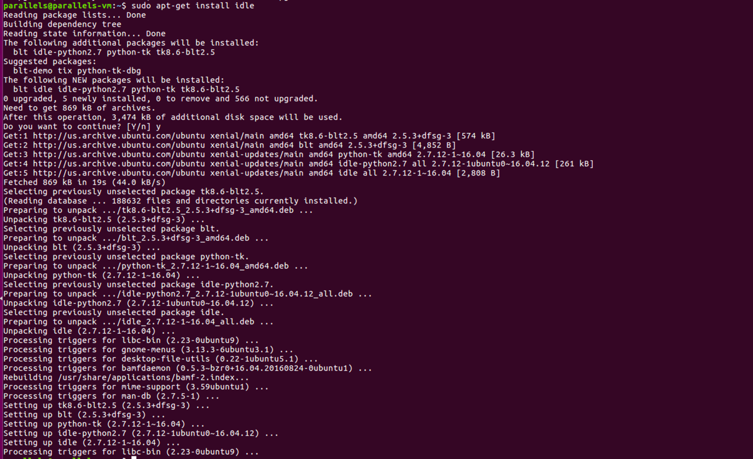

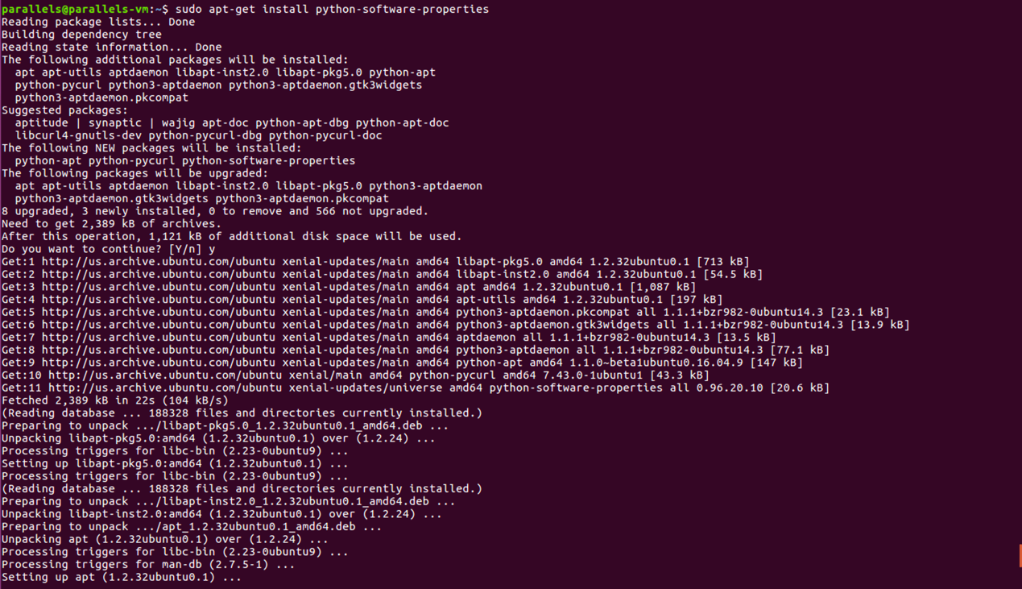

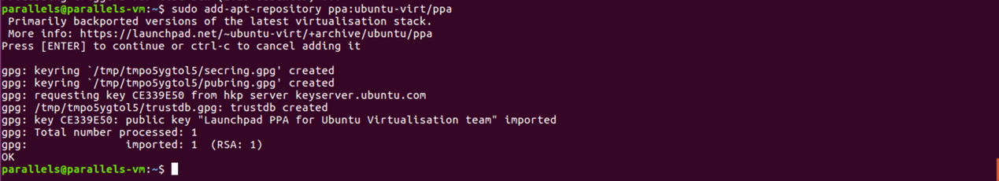

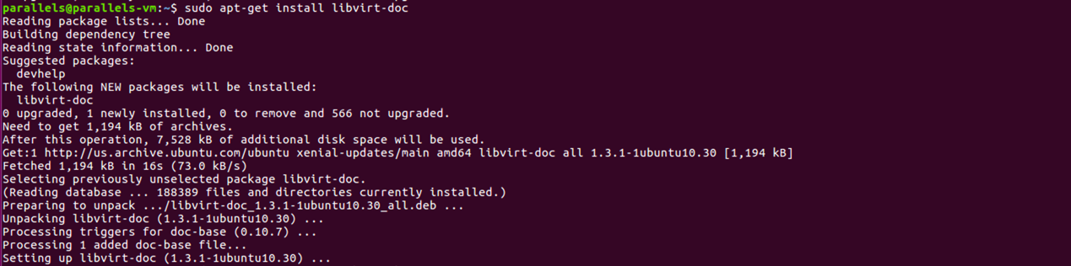

1.2 Install VM

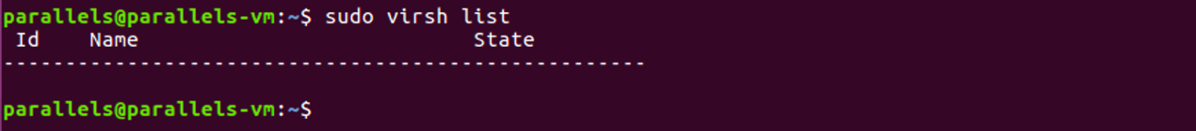

At the beginning, we can see that there is no VM.

To install VM, I create the ***images*** directory under the ***root***, and create the ***iso*** and ***test*** directories under ***images***. The ***iso*** directory stores the ISO image, and ***test*** is the host name of the virtual machine. ***disk.img*** is stored inside it(data stored in the hard disk of virtual machine)

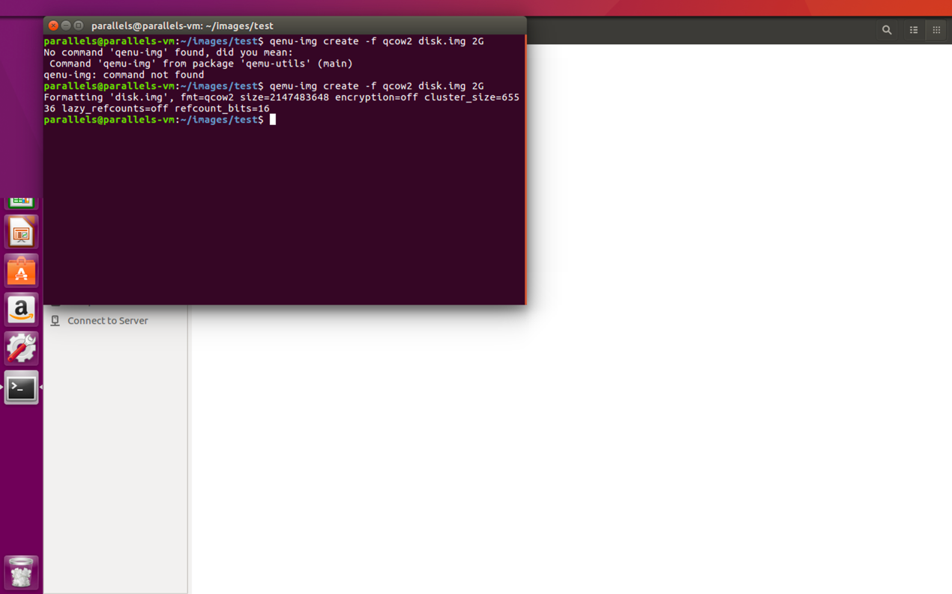

Figure create ***disk.img***

Then we can download an ISO file to the directory we specify, which is also the operating system we need to install.

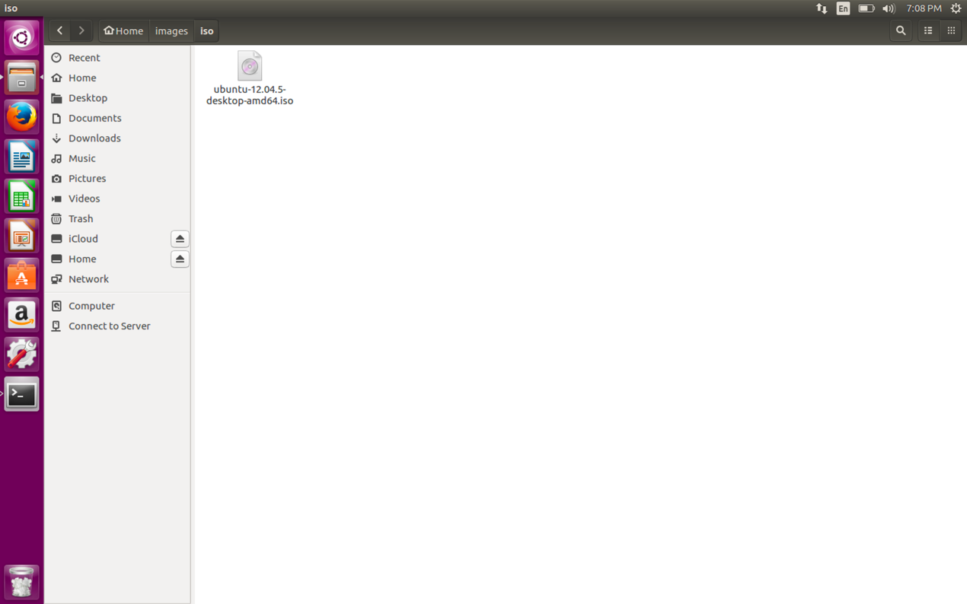

Figure create an ISO file

With all the preparatory work done, we started to create the virtual machine.

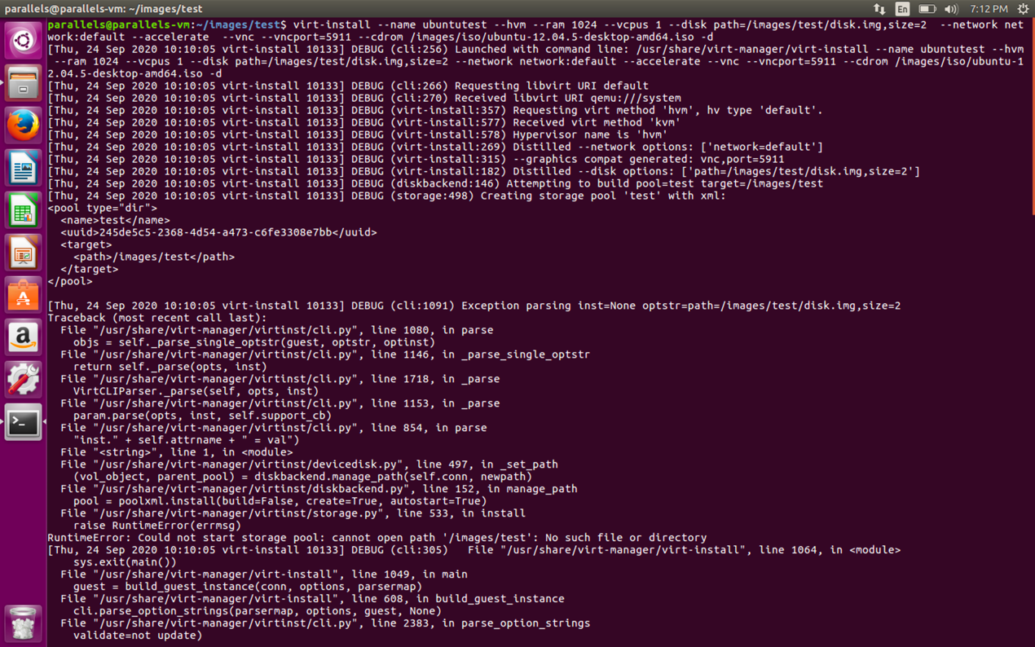

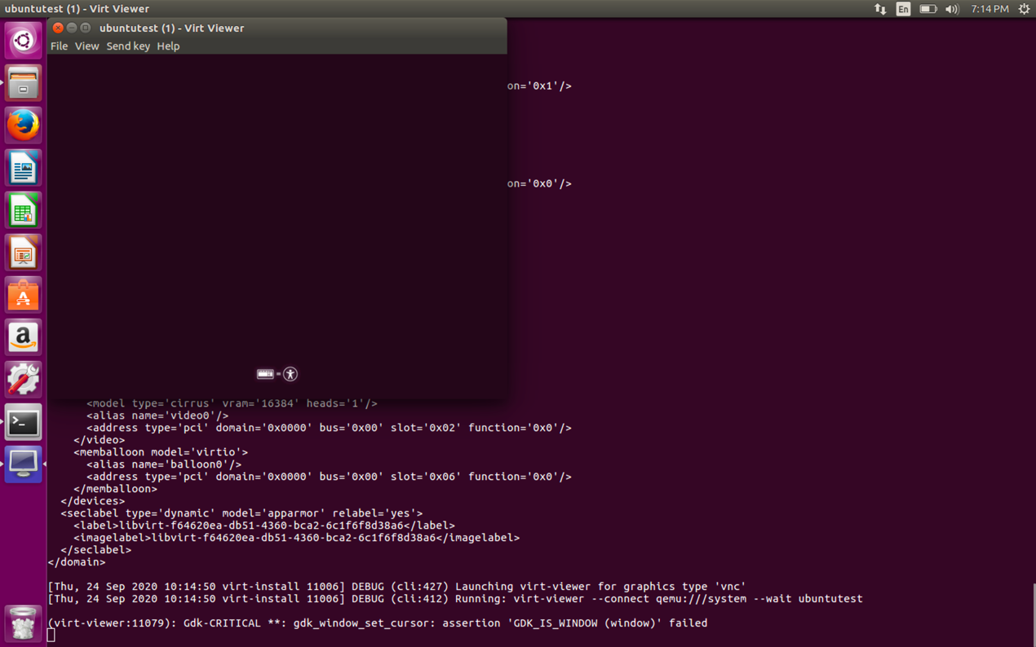

Now check the existence of the VM.

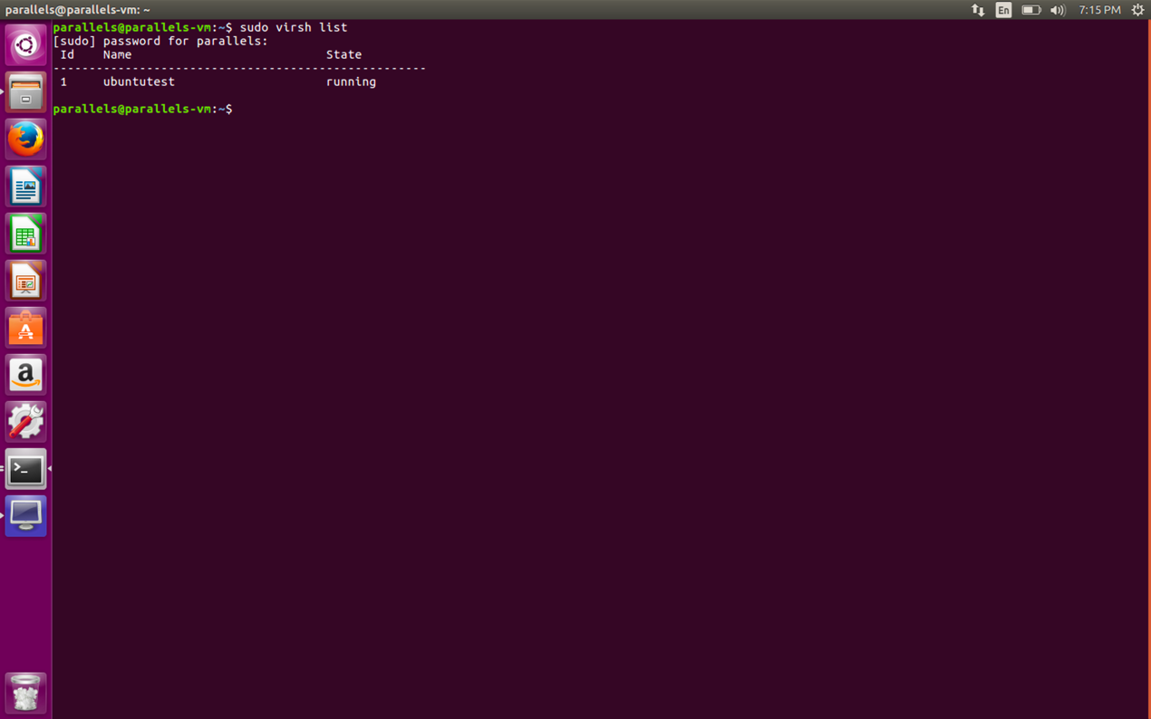

This shows that our virtual machine exists and is named **ubuntutest**.

1.3 Write python script with Libvirt Python to get virtual machine ID, name, max memory, and the number of virtual CPUs.

